Introduction to The Gospels Mike Fuller
- Definitions

The word euangelion (εύαγγελιον) means a beautiful message, or good news. It’s used in the time of the New Testament, but adopted by Christians and becomes a technical term. It first meant the message about Jesus (see Romans 1 ¹⁶), but is then used to introduce the written story (e.g. Mark 1¹); and subsequently for the “heading” of each written account – the (one) Good News, according to x. Later on, during the 2nd century CE, other gospels emerge; but are not widely accepted in the church.

Three of the gospels appear quite similar; because they have a common “synopsis” or summary content, Matthew, Mark and Luke are called the “synoptic gospels”.

2. Genre (or, type of writing)
The gospels would have been a recognisable form of writing in the 1st century; but are different to what we would today describe as “biography”. The three major types of writing were “Acts” (the Acts of the Apostles falls into this group); “Memoirs”, which were collections of stories; and “Lives”, comparable to the gospels.
Two gospels make no mention of Jesus’ childhood; about one third of each describes the last week of Jesus’ life. They are written both to inform (Luke 1 ¹⁻⁴, but also to persuade (John 20 ³¹).
The gospels are written in Greek (the language of culture for the age); there are also about a dozen quotations from Jesus in Aramaic (the spoken language of the area), e.g. Mark 15 ³⁴.

3. “Inspiration” and understanding the gospels

Fundamentalist Fred Conservative Charlie Evangelical Eve Radical Ralph
Those who believe that scripture is infallible – perhaps “dictated” by God – will study the gospels, but have little need for the analysis in the first part of this talk. The further people are to the “radical right”, the more likely they are to consider human shaping of the material.

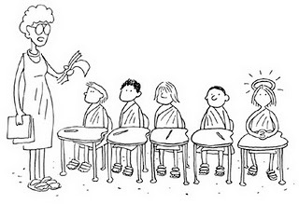
4. Issues raised by reading the synoptic gospels
"Matthew, Mark, Luke, and John, see me after class. Your book reports are surprisingly similar."
a. There is a very close verbal similarity between large parts of Matthew, Mark and Luke: 601 of Mark’s 661 verses are in Matthew and/or Luke. Why is this?
"Matthew, Mark and, Luke: see me after class. Your book reports are surprisingly similar."

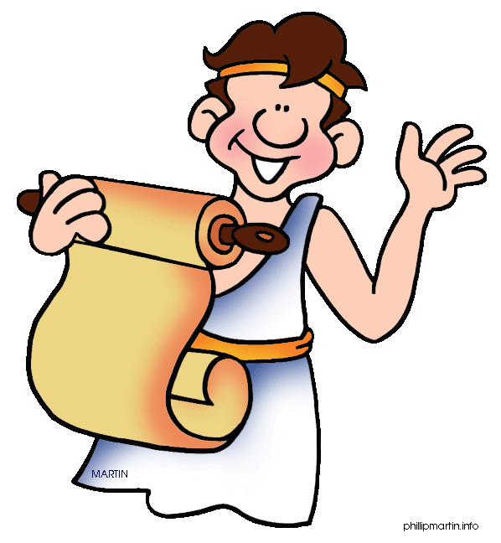
b. Many incidents from the life of Jesus look as though they could have first been circulated by word of mouth as isolated short, sharp stories – which were then linked together into a narrative. How were stories first passed on in “oral tradition”?
c. Luke says he wants to offer an “orderly account” (1 ³); and Matthew offers the teaching of Jesus in five sections – like the five books of the Torah. To what degree are the gospel writers editors, rather than simple writers of narrative?
d. There are 235 verses of Jesus’ teaching in Matthew and Luke that are very similar - but which are absent from Mark (including the Lord’s Prayer). How do we explain this?
e. Both Matthew and Luke contain material which they alone include.
f. There are some small differences between accounts in the synoptic gospels – can we understand why?

5. Tools used to explore the gospel traditions
Source criticism considers the sources used by a writer, usually thinking in terms of documents that they have in front of them as they write.
Form criticism considers the process by which individual units of the gospel story are passed down by word of mouth; and how this may include them being “shaped” into a familiar form, such as a “pronouncement story”, a “miracle story” or a “saying”.

Redaction criticism looks at the way in which a writer shapes material s/he has received in order to reflect particular issues or perspectives

6. A possible explanation of the “Synoptic Question” (see further below for reasons for dating, and possible authorship)
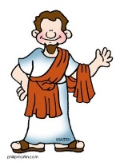

Mark writes his gospel first, drawing on the spoken traditions (and perhaps Peter’s memories)

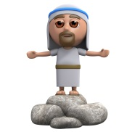
Luke uses Mark’s gospel, plus a collection of teaching that he and Matthew knows, plus his own material (which scholars call “L”)
Matthew uses Mark’s gospel, plus a collection of teaching that he and Luke knows, plus his own material (which scholars call “M”)

Both Matthew and Luke have access to a common source (now lost) of sayings of Jesus, which scholars call “Q” – from the German word for source, Quelle

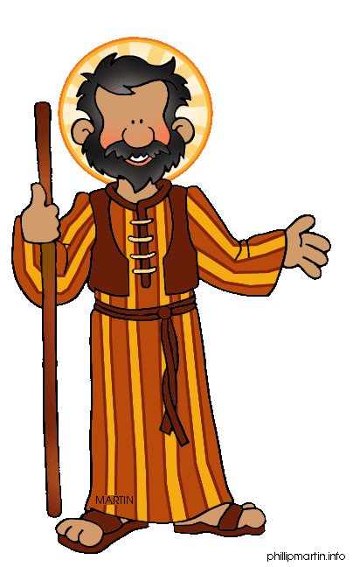
7. Factors that may help us with dating and authorship
a. claims within the text: for example, John ²⁴: “This is the disciple who testifies in these things and who wrote them down …”
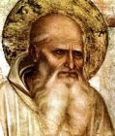
b. assertions of ancient writers: for example Bishop Papias of Hieropolis, who wrote: “… the elder (John?) used to say this, Mark became Peter’s interpreter and wrote accurately all that he remembered, not, indeed, in order, of the things said and done by the Lord …”
c. the implication of changes from Mark to Matthew or Luke: for example, in Matthew Jesus is described as visiting “their” synagogues (4 ²³, 9 ³⁵, 12 ⁹). Does this suggest that the writer is living when Christians were no longer welcome in synagogues? Apparent increased reverence for the Apostles is also held by some to indicate later composition.
d. the way in which the Temple (destroyed by Rome in 70 CE) is referred to: some critical scholars have suggested that the details given in Jesus’ prophecy (Matthew 24, Mark 13, Luke 21) are so accurate that they must indicate a date of writing after 70 CE. However, this claim is founded on the assumption that prophecy can’t be accurate! (You might also argue – as does John Robinson - that the absence of noting the fulfilment of Jesus prophecy indicates that all the gospels were composed much earlier!)

8. Mark’s Gospel
- the shortest gospel
- the least teaching (event after event, with brief sayings of Jesus)
- modest education; vivid language and simple vocabulary; “immediately” a favourite word
- an emphasis on keeping secret the fact that Jesus is Messiah (8 ³⁰)
- account pivots around Caesarea Philippi: after Peter’s recognition of Jesus as Messiah, Jesus sets out to Jerusalem
- some acquaintance with Latin; but probably his first language was Aramaic, not Greek
- limited knowledge of geography of Israel
- not writing for Jews
- perhaps writing in a situation of persecution
- frequent mention of Peter’s mistakes
Written (perhaps in Rome) by John Mark, companion of Paul (see Acts 12 ¹²), using Peter’s recollections; in the early 60s. Some incidental details (e.g. 14 ⁵¹) may be Peter’s eye-witness contributions.

The ending of Mark presents questions. The best manuscripts stop in mid-sentence at 16 ⁸ ; the last verses are almost certainly added later.

9. Matthew’s Gospel
- written by a Jewish Christian with a sort of love-hate relationship to the Jews
- written systematically in educated Greek
- as does Luke, Matthew records Jesus’ miraculous birth
- the book starts with a “genealogy of Jesus, the Messiah, the son of David, the son of Abraham …” (1 ¹).
- the book is shaped with five thematic sections of Jesus’ teaching, reflecting the Torah: (5-7, the Sermon on the Mount; 10, on mission; 13, the parables of the Kingdom; 18, church discipline; the End, 24-25). Each is concluded with a formulaic summary: “… when Jesus had finished teaching, …”
- Jesus’ criticism of Scribes and Pharisees is unrelenting: e.g. 23. He also describes actions of “the Jews” (Matthew 28 ¹⁵). Some argue that this places Matthew’s gospel at a time when Christians and Jews had become completely separate - possibly after the Council of Jamnia (90 CE), although this is now thought less certain
- Matthew uses a list of fulfilled prophecies, which he introduces with “This happened to fulfil what was spoken …”
- there are frequent OT echoes: out of Egypt, in the wilderness, the law given on a mountain
- a key term is “righteousness”
- Jesus says, “Do not think that I have come to abolish the Law and the Prophets”
- the only synoptic writer with the word “church” on Jesus’ lips
- the dependence on Mark may make an eye-witness author unlikely
- ancient writers talk of Matthew writing in Hebrew – but the text doesn’t seem to indicate this
- early traditions that the author was Matthew the tax-collector were unchallenged
Probably written by an unknown Jewish Christian in the 80s, for believers facing bitter conflict with Judaism; perhaps the disciple Matthew wrote another gospel that did not survive?

Matthew’s individual source has much of Jesus’ teaching on hell; and also some of the wackier miracles (the coin in the fish’s mouth, holy people raised when Jesus dies). On two occasions, Matthew records two people where Mark only has one (the Gerasene demoniac, and the blind man Bartimaeus at Jericho). Radical scholars suggest that this is to provide the required two witnesses; conservative scholars say Mark simply focussed on the main character.

10. Luke’s Gospel
- the first part of a two-volume work addressed to Theophilus (perhaps a literary patron?), continued in Acts. The language and structure of the two works confirms this.
- Acts has sections written in the first person (e.g. 16 ¹⁰⁻¹⁷, 20 ⁵⁻¹⁻⁵). This points to “our dear friend Luke, the doctor” (Colossians 4 ¹⁴); which is supported by early writings such as the Muratorian Canon , and Irenaeus (c 180 CE).
- Luke’s Greek is sophisticated, with a rich vocabulary; and his historical references suggest careful research.
- Luke’s gospel has four main sections: introduction, births of John the Baptist and of Jesus, and the only reference to Jesus’ childhood (1 ¹ – 4 ¹³); ministry in Galilee (4 ¹⁴ - 9 ⁵⁰); Jesus’ journey to Jerusalem, including a lot of teaching on discipleship (9 ⁵¹ – 19 ²⁷); and the final week in Jerusalem (19 ²⁸ – 24 ⁵³).
- Luke’s account appears to be written for non-Jewish readers (things that Mark explains, and Matthew simply includes, Luke may omit).
- his personal sources (which presumably include Mary, the mother of Jesus) includes stories and teaching on salvation, wealth and poverty, prayer, women, praise, and the Holy Spirit. He includes more parables than any other gospel writer.
- only Luke describes the ascension.
- if Luke is written before Acts; and Acts does not record the death of Paul; this suggests dating quite soon after Mark, in the mid-60s.
Written by Luke, the “beloved physician”, to non-Jewish readers in the mid-60s. His purposes might include offering an intellectually coherent account; and summarising material for defending Paul (and the Christian faith).

- Some of Luke’s historical references are hard to tie in with other historical evidence. There is no record of a worldwide census decreed by Augustus (2 ¹); and there is debate as to whether Quirinius was Governor of Syria (2 ²) at the time.

11. The synoptics and John: the questions
- the synoptics record Jesus travelling to Jerusalem at the end of his adult life, having ministered extensively in Galilee. John tells us of Jesus attending at least three different Passover festivals (2 ¹³, 6 ⁴, 13 ¹).
- in the synoptics, much of Jesus’ teaching is in parables and short sayings; in John, Jesus makes long speeches, and is involved in extended dialogue with his opponents.
- in the synoptics, those who are healed – and demons – are characteristically commanded not to speak of Jesus being Messiah. In John, Jesus makes frequent and public claims to be God (for example, in the “I am” sayings, and in declaring “Anyone who has seen me has seen the Father” 14 ⁹).
- the synoptics portray the Last Supper as a Passover meal (Mark 14 ¹⁶). John tells us that Jesus’ death – the next day – was before the Passover (19 ³¹).
Critical scholars claim that this casts doubt over John’s historicity – they suggest that the discourses (and claims) attributed to Jesus are written by John in the “spirit” of what Jesus might have said. The Passover is changed so that the “Lamb of God” dies at the same time as the sacrifice.
Conservative scholars suggest that John draws on authentic recollections of Jesus’ teaching, which he has meditated on deeply in his advancing age. The more provocative sayings are placed in Jerusalem, during visits that the synoptics don’t report. Different calendars (and the start of a Jewish day at dusk) may explain the apparent disagreement of when Passover was.

12. John’s gospel
- the most theological gospel – written with a comparatively simple vocabulary, yet with countless layers of deep meaning.
- begins – like Genesis – at the start of time
- describes Jesus as the “Logos” – perhaps connecting with philosophers he has later encountered in his retirement years at Ephesus.
- the gospel is shaped around seven “signs” (2 ¹⁻¹¹, 4 ⁴⁶⁻⁵⁴, 5 ¹⁻¹⁸, 6 ⁵⁻¹⁴, 6 ¹⁶⁻²⁴, 9 ¹⁻⁷, 11 ¹⁻⁴⁵). Jesus’ resurrection is then the final “sign”.
- apparent omissions from the synoptics’ accounts are instead related by allusion: there is no institution of the “Last Supper”, but Jesus is the Bread of Life and the True Vine.
- Jesus makes a series of “I am” claims – a thinly veiled claim to divinity, referring to the sacred name of God in Exodus 3 ¹⁴.
- John doesn’t use the synoptics’ framework; but it may be that he is assuming that his readers already know this account.
- the text of the gospel claims the eye-witness testimony (1 ¹⁴, 19 ³⁵, 21 ²⁴) of the “disciple whom Jesus loved”.
- Irenaeus says that John the apostle was the author
- critical objections to this tradition (for example, based on the author’s competence in Greek) are given less credence today.
Most likely written by the apostle John in Ephesus, towards the end of the first century – or even earlier. There is a fragment of John’s gospel (in the John Rylands Library, Manchester) which has been dated to 125 CE.

One of the most treasured passages in John – the account of the woman taken in adultery, 8 ¹⁻¹¹ – isn’t in the most ancient manuscripts (although Papias, c 70-163 CE, was probably aware of it.

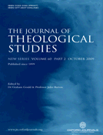

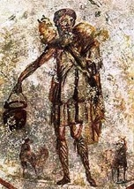
A pastoral footnote:
Jesus, the Good Shepherd: from the catacombs in Rome, 3rd century CE
The best way to know about God is to look at Jesus.
The best way to know about Jesus is to explore the Bible.
Don’t worry if your brain hurts!

Further reading:
An excellent review of today’s thinking on the gospels can be found in David Wenham and Steve Walton: Exploring the New Testament: SPCK 2001

C.H. Dodd, The Apostolic Preaching and its Development: Hodder & Stoughton 1936: suggests that Mark’s gospel is shaped on the outline of Peter’s preaching at Cornelius’ home in Acts 10 ³⁴⁻⁴³ – so he starts with the “beginning” of the gospel
² e.g. The Arabic Gospel of the Infancy, The Gospel of Thomas. See Michael Green: The Books the Church Suppressed: Monarch 2005
“Criticism” means evaluation, not criticising!
John A. T. Robinson: Redating the New Testament: SCM, 1976
for an easy introduction to each gospel, it’s hard to beat The New Lion Handbook to the Bible: Alexander, Pat & David (Eds): Lion 2009: £13.60. Lots of pictures!
Papias says that “the elder” (probably John) recounted accurate stories but with little knowledge of their order. Much of this history is eventually collated by Eusebius – most easily accessed in something like J. Stevenson, A New Eusebius: SPCK 1987
this name literally means “one who loves God”
a late 2nd century list of canonical books
see Richard Bauckham: Gospel of Glory: Baker Academic 2015; chapter 8.
Irenaeus was taught by Polycarp, who in turn was said to have been instructed by John.

